**COMPUTER NETWORKS**

**NAME: M.ISTAFA MALIK**

**ROLL: P190033**

**SECTION: BSCS-5A**

**Task 1: Determine Network Address of the following IP Address.**

**Solution:**

IP Address: 10.128.240.50/30

Subnet Mask: 255.255.255.252

**Binary Conversion:**

IP Address: 000001010. 10000000. 11110000. 00110010

Subnet Mask: 11111111. 11111111. 11111111. 11111100

**AND:**

Now, Applying AND on both IP & Subnet Mask.

000001010. 10000000. 11110000. 00110000

Network Address: 10.128.240.48

Broadcast Address: 10.128.240.51

Number of Hosts: (2^2) – 2 = 2

**Task 2: Determine the network and broadcast addresses and number of hosts bits and hosts for the given IPv4 addresses and prefixes in the following table.**

**Solution:**

|  |  |  |  |  |
| --- | --- | --- | --- | --- |
| **IPV4 Addresses/Prefix** | **Network Address** | **Broadcast Address** | **Total Number of Host Bits** | **Total Number of Hosts** |
| **192.168.100.25/28** | **192.168.100.16** | **192.168.100.31** | **4** | **14** |
| **172.30.10.130/30** | **172.30.10.128** | **172.30.10.131** | **2** | **2** |
| **10.1.113.75/19** | **10.1.96.0** | **10.1.127.255** | **13** | **8190** |
| **192.133.219.250/24** | **198.133.219.0** | **198.133.219.255** | **8** | **254** |

1. **IP address and Subnet Mask: 192.168.100.25/28**.

**Binary Conversion:**

IP Address: 11000000. 10101000. 01100100. 00011001

Subnet Mask: 11111111. 11111111. 11111111. 11110000

**AND operation:**

11000000. 10101000. 01100100. 00010000

Network Address: 192.168.100.16

Broadcast Binary: 11000000. 10101000. 001100100. 00011111

Broadcast Address: 192.168.100.31

Host Bits = 4

Total Number of Hosts = (2^4) – 2 = 14

1. **IP Address and Subnet Mask: 172.30.10.130/30**

**Binary Conversion:**

IP Address: 10101100. 00011110. 00001010. 10000010

Subnet Mask: 11111111. 11111111. 11111111. 11111100

**AND operation:**

10101100. 00011110. 0001010. 10000000

Network Address: 172.30.10.128

Broadcast Binary: 10101100. 00011110. 00001010. 10011111

Broadcast Address: 192.168.100.31

Host Bits = 2

Total Number of Hosts = (2^4) – 2 = 2

1. **IP Address and Subnet Mask: 10.1.113.75/19**

**Binary Conversion:**

IP Address: 00001010. 00000001. 01110001. 01001011

Subnet Mask: 11111111. 11111111. 11100000. 00000000

**AND:**

00001010. 00000001. 01100000. 00000000

Network Address: 10.1.96.0

Broadcast Binary: 00001010.00000001.01111111. 11111111

Broadcast IP: 10.1.127.255

Host Bits: 13

Total Number of Hosts = (2^13) – 2 = 8190

1. **IP Address and Subnet Mask: 198.133.219.250/24**

**Binary Conversion:**

IP Address: 11000110. 10000101. 11011011. 11111010

Subnet Mask: 11111111. 11111111. 11111111. 00000000

**AND:**

And = 11000110. 10000101. 11011011. 00000000

Network Address: 198.133.219.0

Broadcast Binary: 11000110. 10000101. 11011011. 11111111

Broadcast IP: 198.133.219.255

Host Bits = 8

Total Number of Hosts = (2^8) – 2 = 254

**Task 3:** Network Topology A In Part 1, you have been given the 192.168.10.0/24 network address to subnet, with the following topology. Determine the number of networks needed and then design an appropriate addressing scheme.

Step 1: Determine the number of subnets in Network Topology A. a. How many subnets are there? ___2________

b. How many bits should you borrow to create the required number of subnets? ____1 bit_____

c. How many usable host addresses per subnet are in this addressing scheme? __126_________

d. What is the new subnet mask in dotted decimal format? ___255.255.255.128______

e. How many subnets are available for future use? ____0__________

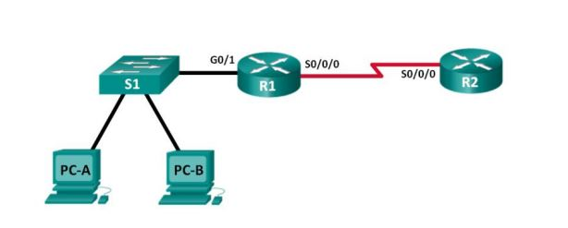

Step 2: Record the subnet information. Fill in the following table with the

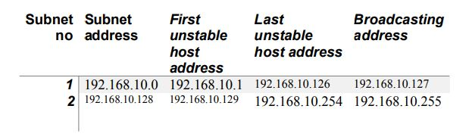

**Task 4:** Network Topology B The topology has changed again with a new LAN added to R2 and a redundant link between R1 and R3.

Use the 192.168.10.0/24 network address to provide addresses to the network devices. Also provide an IP address scheme that will accommodate these additional devices. For this topology, assign a subnet to each network.

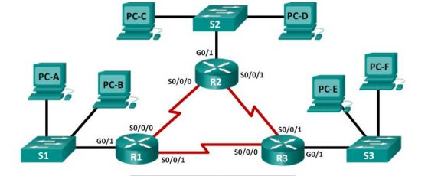

Step 1: Determine the number of subnets in Network Topology B.

a. How many subnets are there? ____6_______

b. How many bits should you borrow to create the required number of subnets? _____3____

c. How many usable host addresses per subnet are in this addressing scheme? _____30______

d. What is the new subnet mask in dotted decimal format? ___255.255.255.244_________.

e. How many subnets are available for future use? ____

Step 2: Record the subnet information. Fill in the following table with the

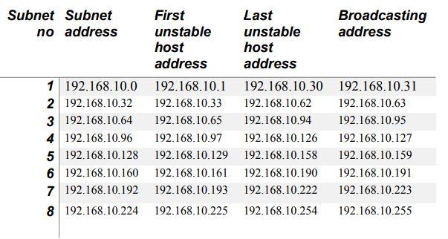

Step 3: Assign addresses to network devices in the subnets.

1. Fill in the following table with IP addresses and subnet masks for the router interfaces:

